ME 389   
Spring 2017  
  
PRO 01

HVAC Temperature Control   
  
Block 6: 4/18 – 4/27  
  
Group 8  
Malcolm Erdongen, Brian Loughran  
  
ABSTRACT

In this report we attempt to control the temperature in a controlled, simplified HVAC (Heating, Ventilation and Air Conditioning) system. A semi-enclosed tube houses a constant speed fan and a variable voltage heating lamp to control the temperature in the enclosure. Attempts to control the temperature include ON/OFF control, as well as a PI controller.

**Introduction:**

HVAC temperature control is crucial to the comfortable inhabitance of most buildings and homes. Generally a sensing device (thermocouple) is used to compare the actual temperature state with a target state, and a control system chooses an appropriate action.

In this lab, first the system is modeled using a first order transfer function. Next, an ON/OFF controller is applied to the system experimentally, and performance is evaluated for the controller. Next, using the system model a PI controller is developed to meet rise time and overshoot specifications.

**Apparatus and Procedure**

This experiment is a small scale model of a real world HVAC system. A figure is shown below to show the apparatus of the experiment (Figure 1):

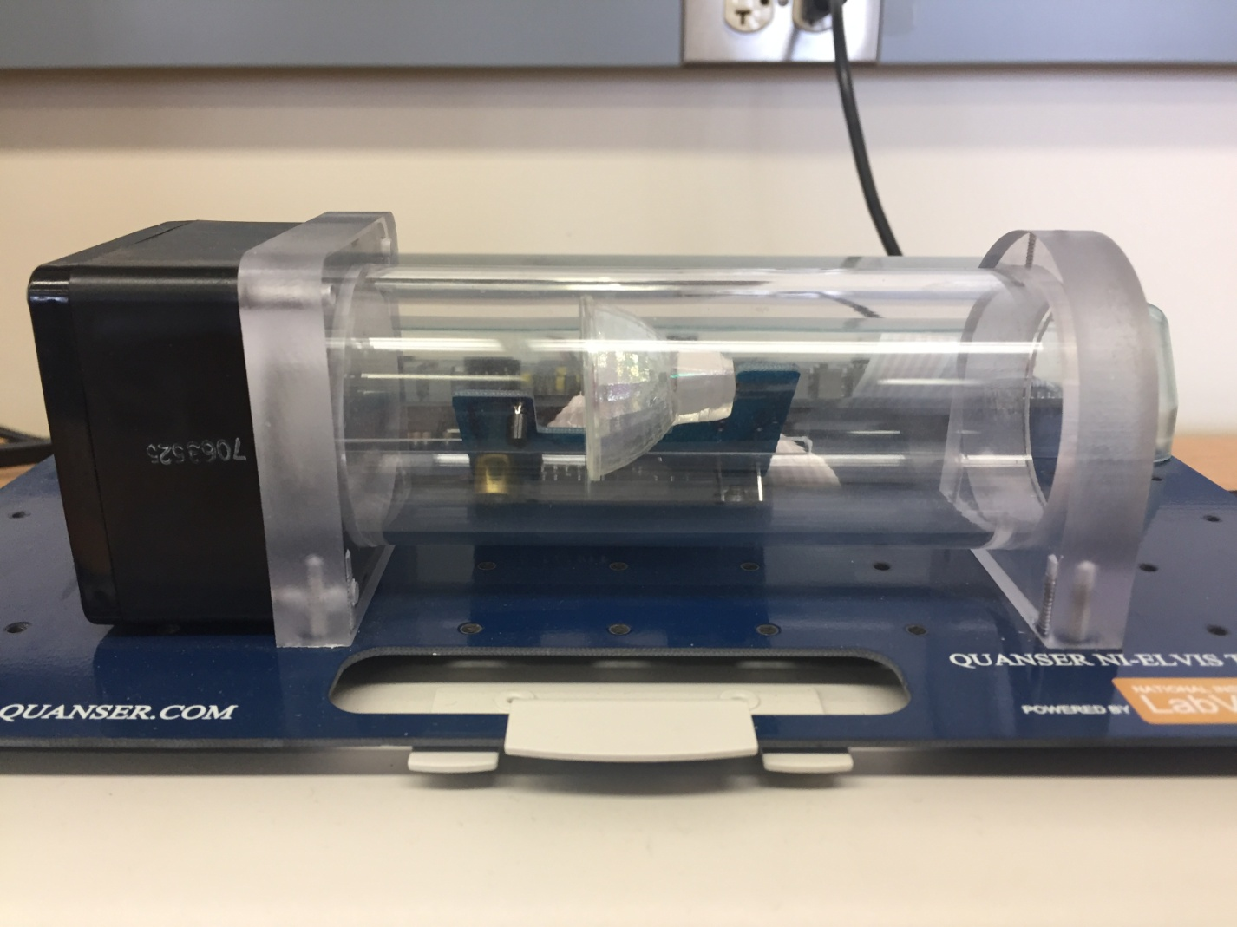

Figure 1 – Apparatus of HVAC lab experiment

In the figure above you can see that the experiment consists a few key components. The system is partially enclosed within a plexiglass duct through which air can move freely. On the left hand side you can see a variable speed fan. For simplicity in this experiment, this will be maintained at a constant speed. At about the midpoint of the plexiglass duct you can see a halogen heating lamp which is used to add heat to the system. This lamp can be controlled from 0V to 5V. A thermocouple is located right in front of the halogen lamp to give a temperature reading for the system. Another thermocouple is located outside the system to measure room temperature.

The system is modeled assuming a first order transfer function for the system with a stable pole in the left hand plane. We determined steady state gain *k*  and the time constant *τ* from experimental data. We assumed a plant *G(s)* to be of the form shown in equation 1:

$$G\left(s\right)= \frac{k}{τs+1} (Equation 1)$$

Two controllers were designed in an attempt to control the temperature of the system. The first was an ON/OFF controller. The general idea for this controller is to turn the heater on when the temperature is measured to be below a desired value, and turned off when the temperature is measured to be above a desired value. To avoid chattering, a hysteresis was added to the controller switch. For improved performance of the system, a PI controller was designed to vary the heater voltage between 0V and 5V.

**Control Design: PI Temperature Control**

In this section we were asked to design a controller to meet a rise time of less than 6s and an overshoot of less than 10%. The PI controller was selected because the integral control was necessary to remove steady state error in tracking the step reference. Our PI controller was of the form shown in equation 2 below:

$$PI= \frac{K_{P}s+ K_{i}}{s} (Equation 2)$$

To achieve our requirements for rise time and overshoot we must first close the loop between our model and our controller. This is done using the feedback equation, and the result of this for our model is shown in the equation below (equation 3):

$$\frac{T(s)}{T_{r}(s)}= \frac{0.252 k_{p}s+0.252 k_{i}}{s^{2}+ \frac{4.6 k_{p}+ 1}{18.28} s+0.252 k_{i}} (Equation 3)$$

The denominator of this equation can be compared to the following to determine values for damping (ζ) and natural frequency ($ω_{n})$:

$$s^{2}+ 2 ζ ω_{n} s+ {ω_{n}}^{2} (Equation 4)$$

Ideal values for the damping and natural frequency can be determined from our required rise time and overshoot. Equations for these are shown below in equations 5 and 6:

$$M_{P}= e^{\frac{-πζ}{\sqrt{1-ζ^{2}}}} \left(Equation 5\right)$$

$$t_{r}= \frac{1.8}{ω_{n}} (Equation 6)$$

Using this procedure, values for kp and ki can be determined from the feedback equation and control requirements. Our PI controller, when solving for these values is of the form shown in the following equation (equation 7):

$$PI= \frac{0.77 s+ 0.129}{s} (Equation 7)$$

Unfortunately, this controller did not work as expected. Using the stepinfo() command in MATLAB showed that we had a rise time of about 3.1s and an overshoot of about 22.1%, which was out of the acceptable range. Our diagnosis revealed that the pole in the left hand plane was decreasing our rise time, but increasing our overshoot.

We were able to find a controller that worked by empirically tuning the kp and ki constants. Using values of kp and ki equal to 1.5 and 0.2 we were able to get a reasonable response. This response is shown below in figure 1:

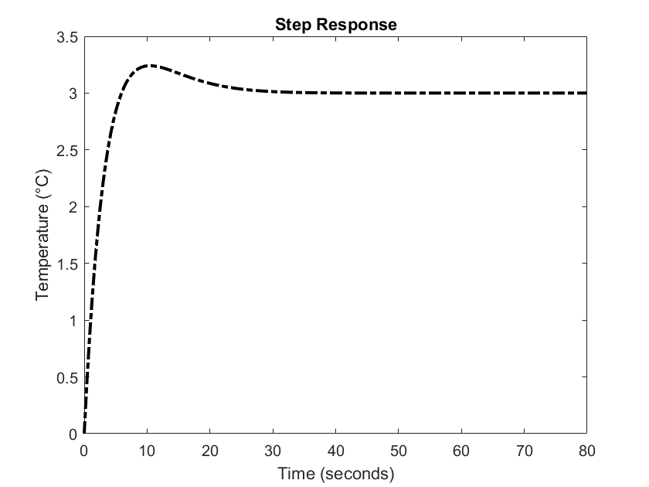

Figure 1 – MATLAB step response of PI controller to 3 degrees (C)

Using the MATLAB command stepinfo() we were able to see that the rise time was equal to 4.1s and that the overshoot was 8.0%. These values were within our range, and therefore this is an acceptable PI controller for this system with these requirements.